Linux Assessment

Name: Nisanth Saravanan
Employee ID: 12576

Question:

Duration : 2 Hours

Task:
Prerequisites : Insall WSL Extension is your VsCode installed on Ubuntu

Note : Take Screen Shots of every step and document it,

- Open the WSL terminal.
- Create folder called LabExercise
- Rename the LabExercise directory to LabWork.
- Move files form old_directory_name to new_directory_name.
- Update package lists using Linux Shell Commands.
- Upgrade packages using Linux Shell Commands.
- Navigate to your project folder using Linux Shell Commands. Open and type vim to create or edit a file.
- Use Vim commands to edit and save the file. Use nano commands to edit and save the file.
- Open the folder in Visual Studio Code run code. Develop C# console code for displaying list of Employees data using .net Core 8.0.
- List all files, including hidden ones using Linux Shell Commands.

Open the WSL terminal

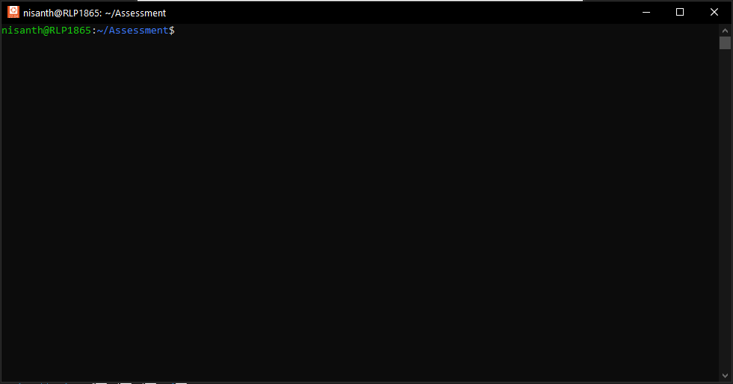

Create folder called LabExercise

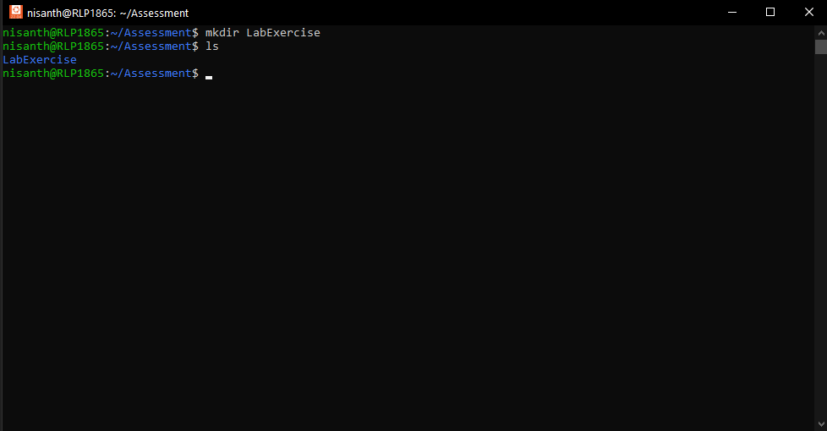

The command mkdir allows the user to create an empty directory in the current working directory.

Rename the LabExercise directory to LabWork

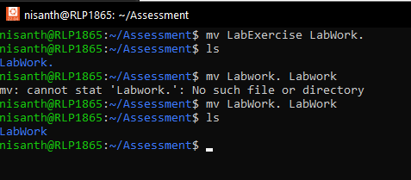

As the directory “LabWork” doesn’t exist, the mv command simply renames the “LabExercise” directory.

But, if a directory specified in the “new_directory” of the command’s syntax, then the mv command would have moved the entire directory into the specified directory.
Move files form old_directory_name to new_directory_name

*Moving Directory: The entire directly is being moved into a pre-existing directory.

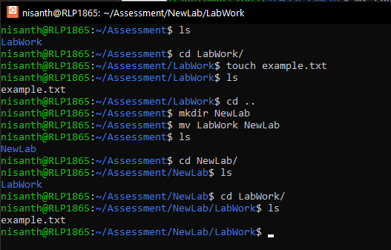

*Moving A File Alone: The specific file alone is being moved into a pre-existing directory.

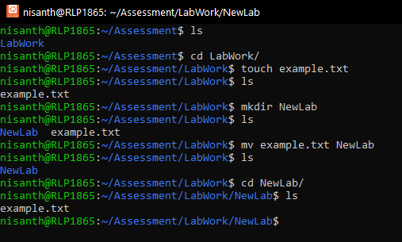
Update package lists using Linux Shell Commands

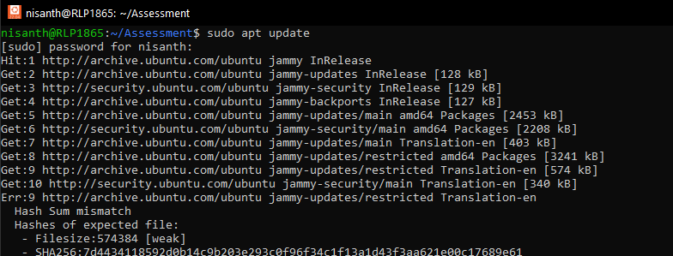

Upgrade packages using Linux Shell Commands

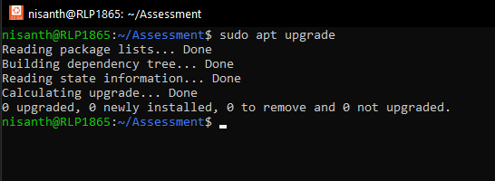
Navigate to your project folder using Linux Shell Commands. Open and type vim to create or edit a file

Navigation to desired directory:

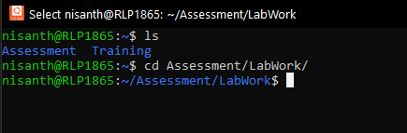

Using VIM editor:

If the specified filename doesn’t exist in the directory, a new file in the said name will be created.

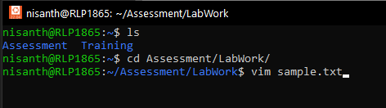

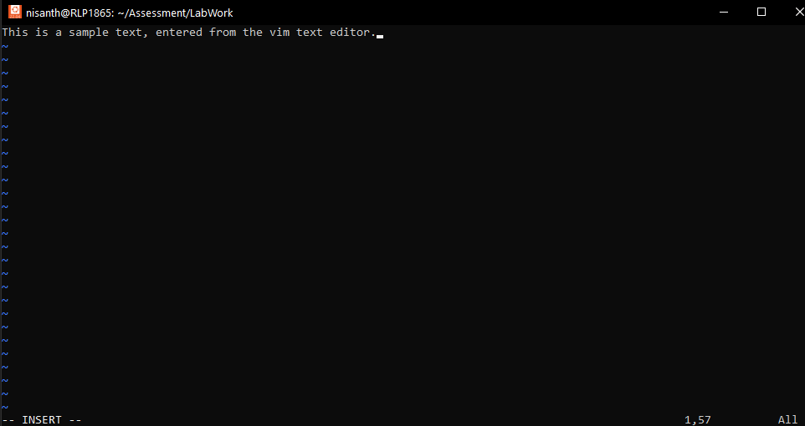

Press “Esc” to exit INSERT mode. Type in “:wq” to write out and quit the editor,
The specified command will be shown in the bottom left corner of your shell.
This helps in identifying which mode the VIM editor is in.

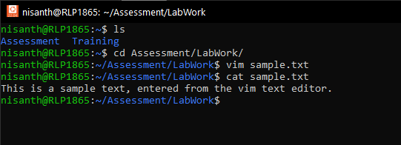

Editing using VIM editor:

But if the file does exist, then it counts as editing a pre-existing file, and doesn’t create a new one without any purpose.

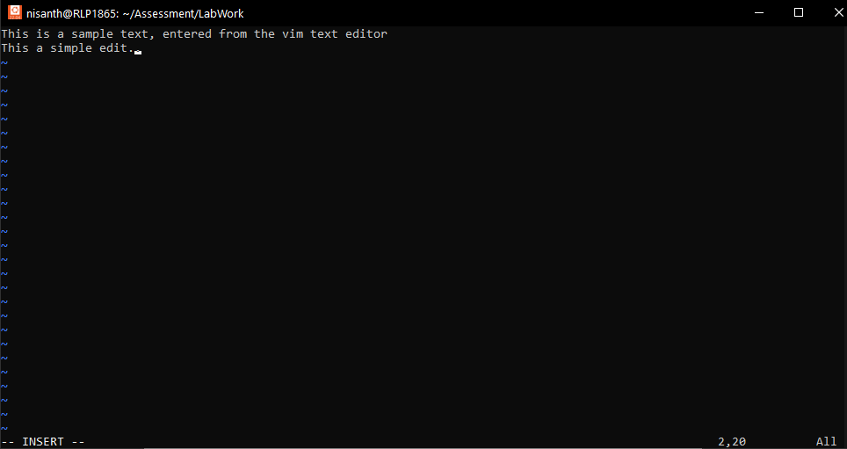

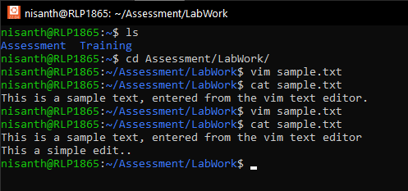
Use Vim commands to edit and save the file. Use nano commands to edit and save the file

Using VIM:

If the specified filename doesn’t exist in the directory, a new file in the said name will be created.



Press “i” to enter INSERT mode:

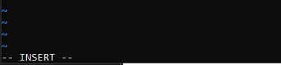

Start typing your text as the cursor appears.



Press “Esc” to exit INSERT mode. Type in “:wq” to write out and quit the editor:

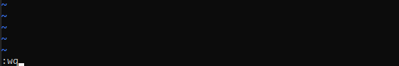

The specified command will be shown in the bottom left corner of your shell.
This helps in identifying which mode the VIM editor is in.



Using NANO:

If the specified filename doesn’t exist in the directory, a new file in the said name will be created.

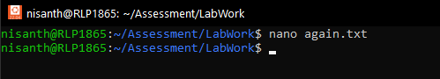

Simply start writing:

Unlike the VIM editor, nano allows user to write as soon as the editor is opened. It contains a helping guide at the bottom to show the users the list of commands to edit and save their file. A very user friendly editor.

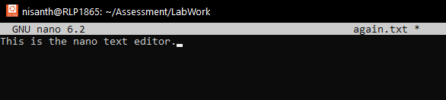

Press “Crtl + O” to write out:

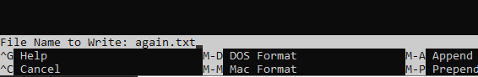

Press “Crtl + X” to exit:

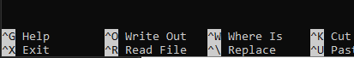

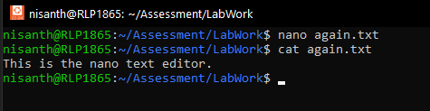

Editing:

But if the file does exist, then it counts as editing a pre-existing file, and doesn’t create a new one without any purpose.

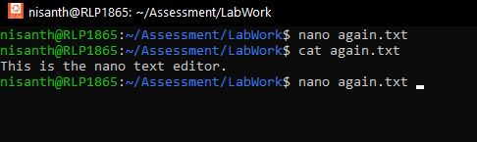

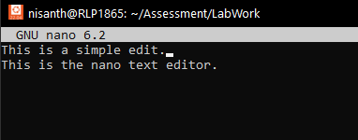

Write out and Exit:

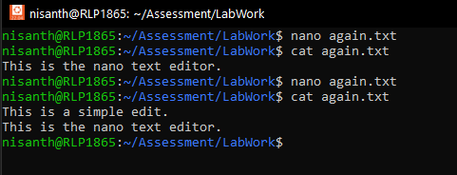
Open the folder in Visual Studio Code run code. Develop C# console code for displaying list of Employees data using .net Core 8.0. :

Creating console app:

Upon using the said command a basic skeletal console app will be created in our current working directory.

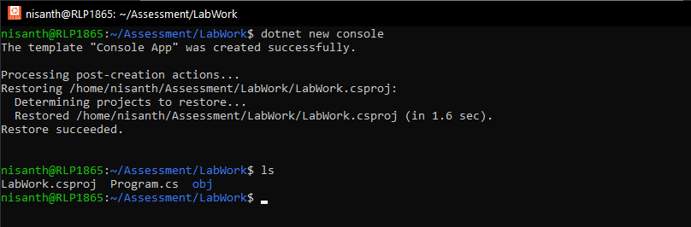

Opening VS Code:

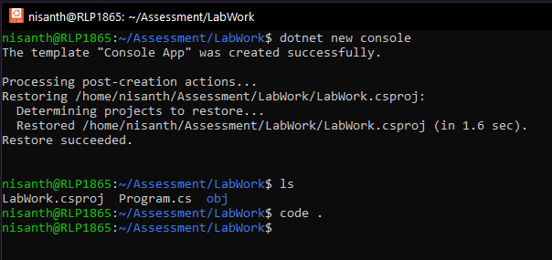

VS Code opened in the WSL environment:

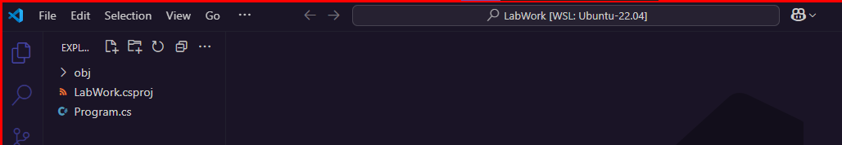

Build the written code:

After being dome with the code, the given command with create the complied build_output folder for the console app to successfully run in Linux Environment.

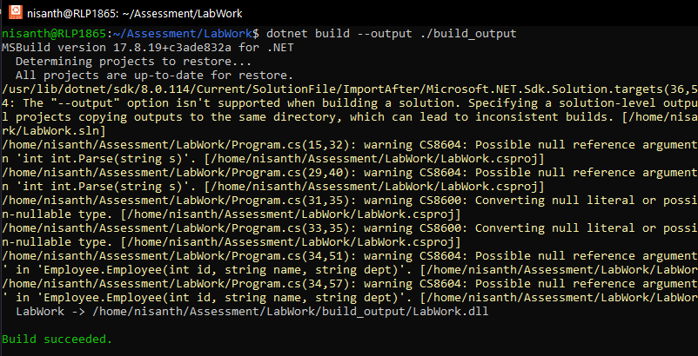

Run the code:

Adding Employee details:

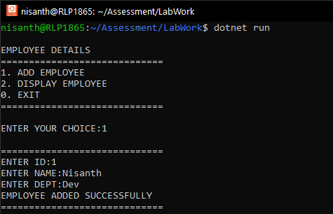
Displaying Employee details:

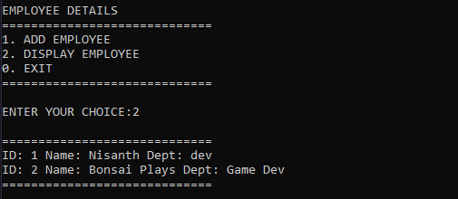

Exiting Application:

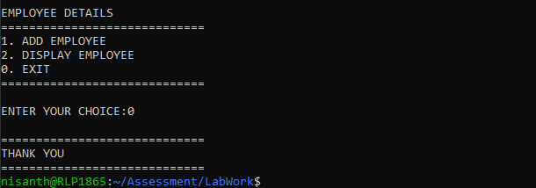
Actual Code

Employee.cs:

public class Employee
{
public int EmpID { get; set; }
public string Name { get; set; }
public string Dept { get; set; }

public Employee(int id, string name, string dept)
{
this.EmpID = id;
this.Name = name;
this.Dept = dept;
}

public static void DisplayEmp(Employee e)
{
Console.Write($"ID: {e.EmpID} Name: {e.Name} Dept: {e.Dept}\n");
}
}
Program.cs:

class Company
{
public static void Main()
{
List<Employee> employees = new List<Employee>();

checkpoint1:
Console.WriteLine("\nEMPLOYEE DETAILS");
Console.WriteLine("=============================");
Console.WriteLine("1. ADD EMPLOYEE");
Console.WriteLine("2. DISPLAY EMPLOYEE");
Console.WriteLine("0. EXIT");
Console.WriteLine("=============================");
Console.Write("\nENTER YOUR CHOICE:");
int choice = int.Parse(Console.ReadLine());
switch (choice)
{
case 0:
{
Console.WriteLine("\n=============================");
Console.WriteLine("THANK YOU");
Console.WriteLine("=============================");
return;
}
case 1:
{
Console.WriteLine("\n=============================");
Console.Write("ENTER ID:");
int id = int.Parse(Console.ReadLine());
Console.Write("ENTER NAME:");
string name = Console.ReadLine();
Console.Write("ENTER DEPT:");
string dept = Console.ReadLine();
Employee e = new Employee(id, name, dept);
employees.Add(e);
Console.WriteLine("EMPLOYEE ADDED SUCCESSFULLY");
Console.WriteLine("=============================");
goto checkpoint1;
}

case 2:
{
Console.WriteLine("\n=============================");
foreach (Employee e in employees)
{
Employee.DisplayEmp(e);
}
Console.WriteLine("=============================");
goto checkpoint1;
}
}

}
}

List all files, including hidden ones using Linux Shell Commands

Using the ls command with -a option:

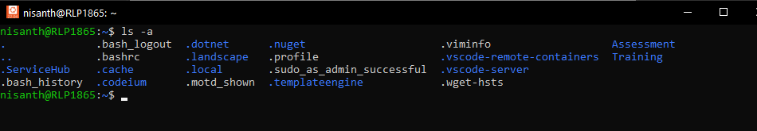

*Note: No hidden files present in the project directory.

